The laboratory work 3
SQL Server on Azure virtual machines enables you to use full versions of SQL Server in the Cloud without having to manage any on-premises hardware. SQL Server VMs also simplify licensing costs when you pay as you go.
Azure virtual machines run in many different geographic regions around the world. They also offer a variety of machine sizes. The virtual machine image gallery allows you to create a SQL Server VM with the right version, edition, and operating system. This makes virtual machines a good option for a many different SQL Server workloads.

Automated updates
SQL Server Azure VMs can use Automated Patching to schedule a maintenance window for installing important windows and SQL Server updates automatically.

Automated backups
SQL Server Azure VMs can take advantage of Automated Backup, which regularly creates backups of your database to blob storage. You can also manually use this technique. For more information, see Use Azure Storage for SQL Server Backup and Restore.

High availability
If you require high availability, consider configuring SQL Server Availability Groups. This involves multiple SQL Server Azure VMs in a virtual network. You can configure your high availability solution manually, or you can use templates in the Azure portal for automatic configuration. For an overview of all high availability options, see High Availability and Disaster Recovery for SQL Server in Azure Virtual Machines.

Performance
Azure virtual machines offer different machine sizes to meet various workload demands. SQL VMs also provide automated storage configuration, which is optimized for your performance requirements. For more information about configuring storage for SQL VMs, see Storage configuration for SQL Server VMs. To fine-tune performance, see the Performance best practices for SQL Server in Azure Virtual Machines.

Get started with SQL VMs
To get started, choose a SQL Server virtual machine image with your required version, edition, and operating system. The following sections provide direct links to the Azure portal for the SQL Server virtual machine gallery images.

Pay as you go
The following table provides a matrix of pay-as-you-go SQL Server images.
Version | Operating System | Edition
SQL Server 2019 | Windows Server 2019 | Enterprise, Standard, Web, Developer
SQL Server 2017 | Windows Server 2016 | Enterprise, Standard, Web, Express, Developer
SQL Server 2016 SP2 | Windows Server 2016 | Enterprise, Standard, Web, Express, Developer
SQL Server 2014 SP2 | Windows Server 2012 R2 | Enterprise, Standard, Web, Express
SQL Server 2012 SP4 | Windows Server 2012 R2 | Enterprise, Standard, Web, Express
SQL Server 2008 R2 SP3 | Windows Server 2008 R2 | Enterprise, Standard, Web, Express
To see the available Linux SQL Server virtual machine images, see Overview of SQL Server on Azure Virtual Machines (Linux).

Bring your own license
You can also bring your own license (BYOL). In this scenario, you only pay for the VM without any additional charges for SQL Server licensing. Bringing your own license can save you money over time for continuous production workloads. For requirements to use this option, see Pricing guidance for SQL Server Azure VMs.
To bring your own license, you can either convert an existing pay-per-usage SQL VM, or you can deploy an image with the prefixed {BYOL}. For more information about switching your licensing model between pay-per-usage and BYOL, see How to change the licensing model for a SQL VM.
Version | Operating system | Edition
SQL Server 2019 | Windows Server 2019 | Enterprise BYOL, Standard BYOL
SQL Server 2017 | Windows Server 2016 | Enterprise BYOL, Standard BYOL
SQL Server 2016 SP2 | Windows Server 2016 | Enterprise BYOL, Standard BYOL
SQL Server 2014 SP2 | Windows Server 2012 R2 | Enterprise BYOL, Standard BYOL
SQL Server 2012 SP4 | Windows Server 2012 R2 | Enterprise BYOL, Standard BYOL
It is possible to deploy an older image of SQL Server that is not available in the Azure portal using PowerShell. To view all available images using Powershell, use the following command:
PowerShell
Get-AzVMImageOffer -Location $Location -Publisher 'MicrosoftSQLServer'
For more information about deploying SQL Server VMs using PowerShell, view How to provision SQL Server virtual machines with Azure PowerShell.

Connect to the VM
After creating your SQL Server VM, connect to it from applications or tools, such as SQL Server Management Studio (SSMS). For instructions, see Connect to a SQL Server Virtual Machine on Azure.

Migrate your data
If you have an existing database, you'll want to move that to the newly provisioned SQL VM. For a list of migration options and guidance, see Migrating a Database to SQL Server on an Azure VM.

Create and manage Azure SQL resources with the Azure portal
The Azure portal provides a single page where you can manage all of your Azure SQL resources including your SQL virtual machines.
To access the Azure SQL resources page, select Azure SQL in the Azure portal menu, or search for and select Azure SQL from any page.
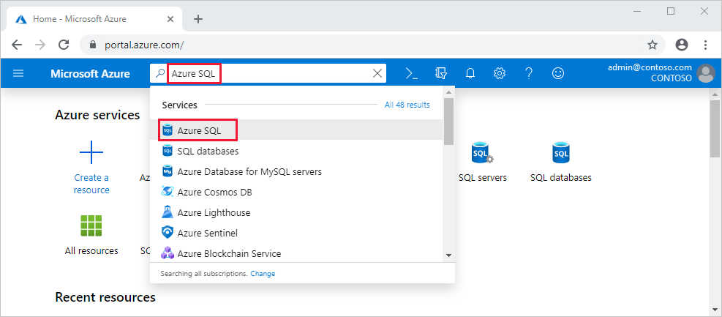
To manage existing resources, select the desired item in the list. To create new Azure SQL resources, select + Add.
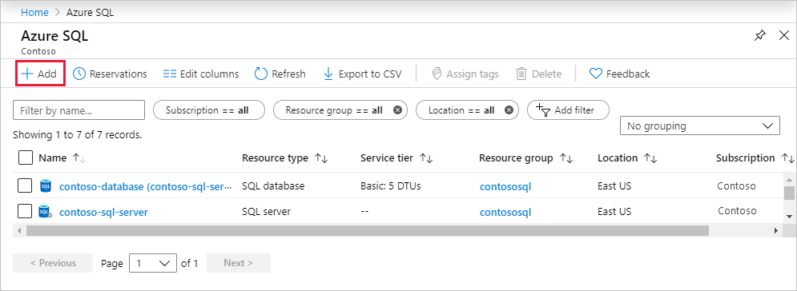
After selecting + Add, view additional information about the different options by selecting Show details on any tile.
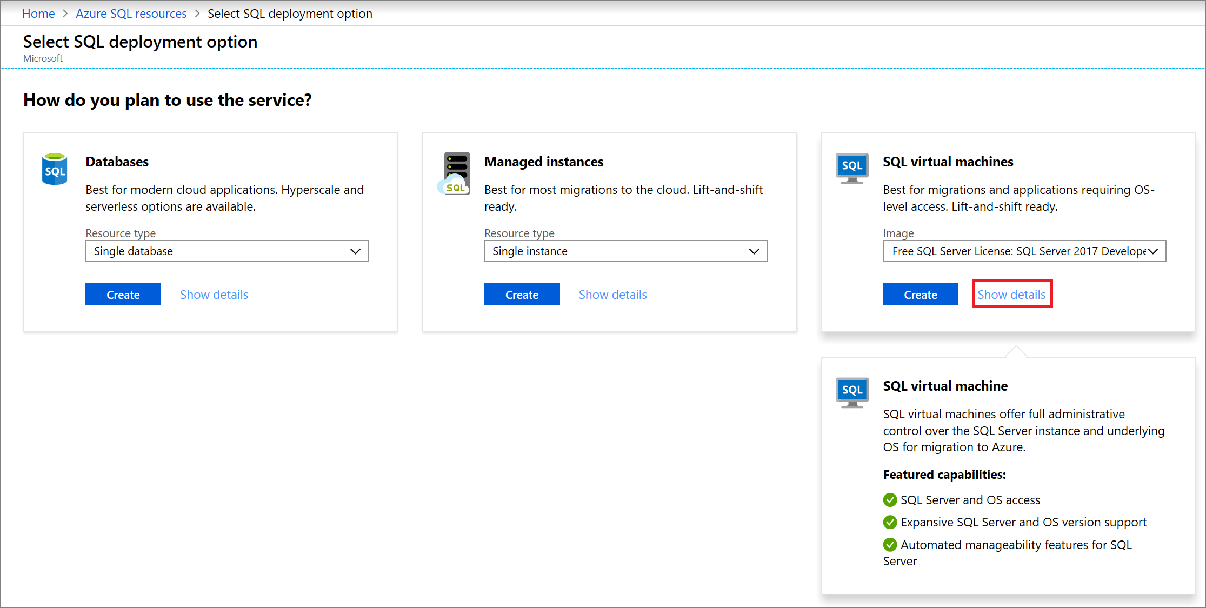
For details, see:
- Create a single database
- Create an elastic pool
- Create a managed instance
- Create a SQL virtual machine

